Harvey, Bruce E
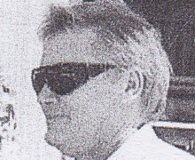
BSc Forestry from ANU 1971. Commenced as Assistant Divisional Forests Officer 1972 in Manjimup Regional Office. Transferred from Manjimup District to Working Plans Office in 1972. At Working Plans Office in 1970s-80s. Regional Leader Operations Bunbury in 1987, transferred to Kelmscott as Regional Operations Officer in 1990. Regional Manager Swan Region in 1996.

